Gradient, y-intercept and the equation of a line
- Remember the gradient of a line is the slope of a line. The slope of a line is determined by how much we then go up and how far we go across.
- Gradient can be represented as a fraction, decimal or whole number.

Example
Circle the line that would have a larger value (number) for its gradient.
To calculate the gradient, we can use the formulae:
$$gradient \left(m\right)= \frac{rise}{run}$$

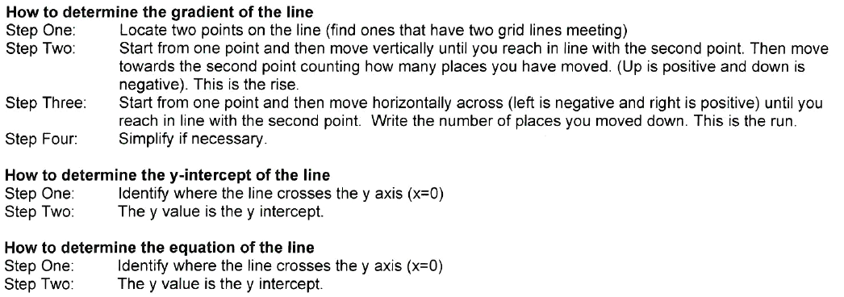

Example:

$gradient \left(m\right)= \frac{rise}{run}= \frac{ }{ }$

$y-intercept \left(c\right)= _________$

$$Equation of the line y=mx+c$$

___________________

$$gradient \left(m\right)= \frac{rise}{run}= \frac{ }{ }$$

$y-intercept \left(c\right)= _________$

$$Equation of the line y=mx+c$$

___________________

$$gradient \left(m\right)= \frac{rise}{run}= \frac{ }{ }$$

$y-intercept \left(c\right)= _________$

$$Equation of the line y=mx+c$$

___________________

$$gradient \left(m\right)= \frac{rise}{run}= \frac{ }{ }$$

$y-intercept \left(c\right)= _________$

$$Equation of the line y=mx+c$$

___________________

$$gradient \left(m\right)= \frac{rise}{run}= \frac{ }{ } gradient \left(m\right)= \frac{rise}{run}= \frac{ }{ }$$

$y-intercept \left(c\right)= _______$ $y-intercept \left(c\right)= _________$

$$Equation of the line y=mx+c Equation of the line y=mx+c$$

___________________ ___________________

$$gradient \left(m\right)= \frac{rise}{run}= \frac{ }{ } gradient \left(m\right)= \frac{rise}{run}= \frac{ }{ }$$

$y-intercept \left(c\right)= _______$ $y-intercept \left(c\right)= _________$

$$Equation of the line y=mx+c Equation of the line y=mx+c$$

___________________ ___________________

$$gradient = gradient=$$

$y-intercept=$ $y-intercept=$

$$Rule: Rule:$$

$$gradient = gradient=$$

$y-intercept=$ $y-intercept=$

$$Rule: Rule:$$

$$gradient = gradient=$$

$y-intercept=$ $y-intercept=$

$$Rule: Rule:$$

